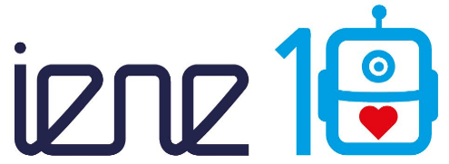

ERASMUS+ Programme – Key Action 2: Strategic partnership
IENE 10 “PREPARING HEALTH AND SOCIAL CARE WORKERS TO WORK WITH SOCIALLY ASSISTIVE ARTIFICIALLY INTELLIGENT ROBOTS IN HEALTH AND SOCIAL CARE ENVIRONMENTS”
Agreement number: 2020-1-UK01-KA202-078802

Newsletter No. 4
June 2022
Introduction |  | The IENE 10 project aims to create a European Transcultural Robotic Nursing (TRN) curriculum and learning materials targeted at health and social care workers and educators.  The TRN curriculum was developed to promote culturally competent and compassionate transcultural nursing through the use of artificial intelligence and socially assistive robots. The TRN curriculum is designed to adapt to current challenges and support the care of people in need. The TNR curriculum also aims to increase knowledge about TRN and create a comprehensive knowledge map about TRN.  In recent months, the learning units have been completed to the point where they could be uploaded to the MOOC platform (APTEM).  Work was also done on the strategy for recruiting facilitators and participants for the MOOC.  The piloting of the MOOC content and the training of the facilitators will take place at the next transnational project meeting in London, UK.  The MOOC will run from September, 30th until November, 4th 2022. Registration is open between August, 15th and September 29th. Information and pre-registration is available at bit.ly/IENEMOOC. |           
Output 4  Setting up the MOOC |  | The creation of the learning units could be completed so far and the content was uploaded to the MOOC platform. The only thing missing were videos introducing the individual modules. These videos were created during the transnational project meeting in Dornbirn, Austria and will be integrated into the MOOC platform in the next few weeks.  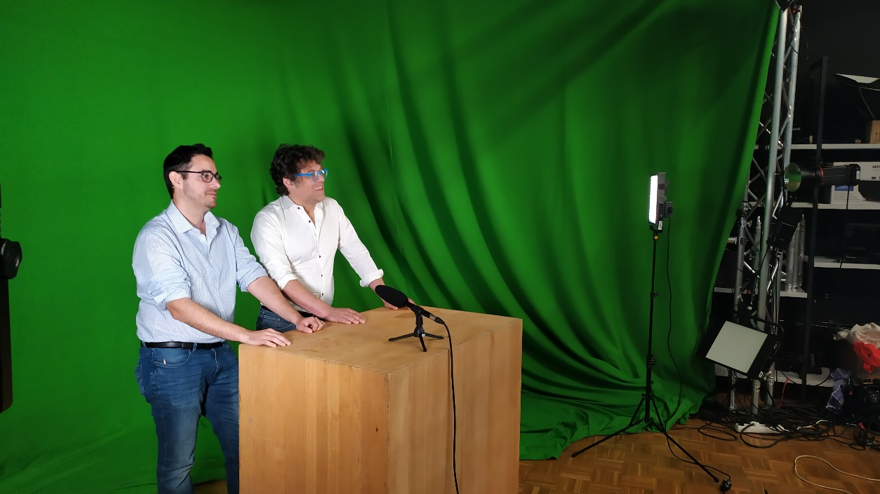
5th Transnational meeting in Dornbirn  (3rd face to face) |  | The aim of the transnational project meeting in Dornbirn was to update the project partners on the activities of all partner organizations. The following points were discussed:  - Update of all partners on  - the completion of the learning unit manual  - the changes of the project website  - the dissemination activities  - finalization and coordination of the recruitment strategy for the MOOC  - production of introductory videos for each module of the MOOC  - Initial familiarization with the MOOC platform and submission of change requests  - Discussion about the recruitment of MOOC moderators and their training  - Discussion about the draft assessment and evaluation strategy  - Discussion about the publishing activities
Next meeting |  | The next meeting will be held in London, UK, in September 2022.
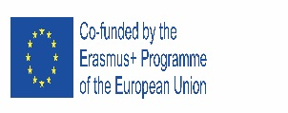  This project has been funded with support from the European Commission. This publication reflects the views only of the author, and the Commission cannot be held responsible for any use which may be made of the information contained therein. |  |         

